

**Rugby Town Junior Football Club**

|  |  |
| --- | --- |
| CASE STUDY THEMES | |
| * Football * Drainage installation * Growth in participation | * Community links * Talent development * Meeting local need |

|  |  |
| --- | --- |
| PROJECT SUMMARY | |
| **Facility name** | Rugby Town Junior Football Club |
| **Lead organisation** | Rugby Town Junior Football Club |
| **Organisation type** | Community |
| **Location** | Rugby, West Midlands |
| **Sport** | Football |
| **Total project cost** | £59,000 |
| **PPF funding** | £50,000 |
| **Other funding sources** | Rugby Town JFC |
| **Tender process** | Sport England Contractor Framework |
| **Contract type** | JCT Minor Works contract |
| **Start and end date** | May 2012 – May 2013 |
| **Duration of capital works** | 3 months |
| **Increased usage achieved per week during season** | 1-2 hours |
| **Achieved outcomes**   * Step change in playing field usage * Increase in number of junior teams and club membership * Contribution to talent development for different abilities and age groups * Expanded use of the pitches by other sporting initiatives * Improved the club’s financial situation | |

**Protecting Playing Fields**



**Introduction**

Rugby Town Junior Football Club has been running for 12 years and currently has approximately 700 members, all of which are children under 18 years old. The Club identified a need to improve the quality of its pitches to improve usage and enable the Club to meet a growing local demand. The Club is an FA Charter Community Status club and already played a vital role in meeting a community need for high quality football facilities. The site is approximately 7 ha and currently comprises 12 football pitches from junior to senior sizes. Although pitches were constructed for the Club as recently as 2005 the pitches suffered with poor turf quality and poor drainage and games were regularly called off because of waterlogged pitches (below). Protecting Playing Fields funding supported drainage improvements on three of the Club’s existing pitches.

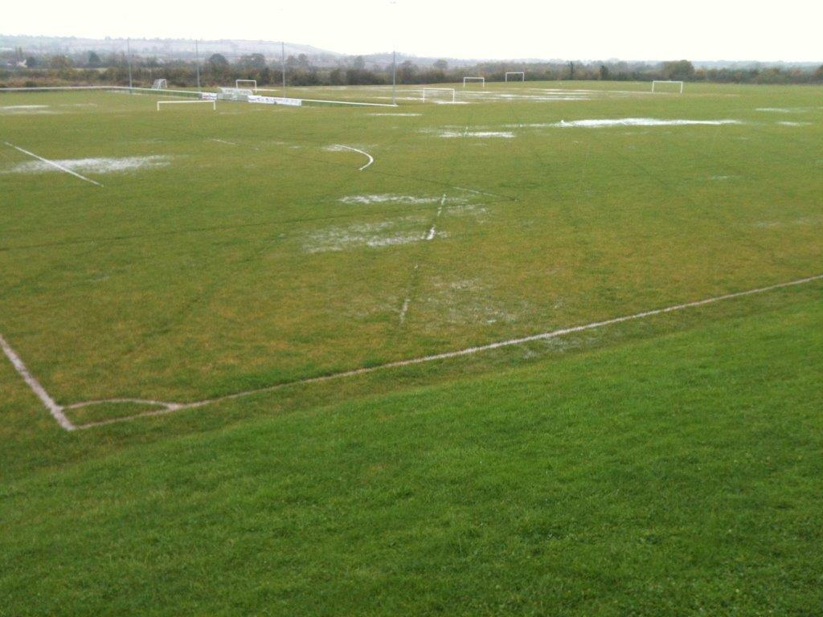

**The Project**

Rugby Town JFC was awarded Sport England funding in the first round of Protecting Playing Fields. An important consideration in the decision to award funding was the Club’s long-term plan to retain and increase participation which includes younger age groups and the number of girl’s teams playing football on a regular basis. After the application was approved Sport England appointed TGMS, a leading sports turf consultancy to scan the site and produce a specification for the installation of a new drainage scheme. TGMS’s feasibility study concluded that the installation of a secondary drainage system on the pitches could improve usage from the current 2 hours per week to up to 9 hours of junior usage per week. A local contractor with previous experience of the site was assessed alongside Sport England’s framework of contractors and considered to offer the best value for money in meeting the specification. The project improved drainage at the scheme by installing new drainage runs as well as slit drains on one senior pitch and two junior pitches. Drainage works commenced on the site in May 2012 and the first pitches were completed and used for the first time at the start of the 2012/13 season.



**Outcomes**

**The Playing Field**

The drainage installation works was overseen by the turf consultant who reported very satisfactory progress at all stages of the project. Topdressing sand was applied to the pitches prior to playing to protect them from smearing over by indigenous soil.

The pitches were first used in September 2012 and continued to be used in the winter while others around the site continued to suffer from excess water. A site visit in October 2012 reported that the pitches were in excellent condition and the club were already starting to see the benefits of less cancellations and higher usage. The pitches performed very well over the first season and remained in excellent condition. The pitches remained playable in January 2014 after some of the worst rainfall ever seen in the area.

**Sports Participation**

A particular effect of the Sport England project has been to increase the number of games being played on the pitches. In the 2011/12 season 104 games were completed on the senior pitches, an average usage of 1.73 games per week. During 2012/13, the first season of usage after the completion of the improvement works, the number of games on the senior pitches rose to 150 games, an average usage of 2.5 games per week. The club expect the number of games taking place on the senior pitches to continue to rise in the future and anticipate a usage of 232 games in season 2016/17. With similar trends in usage on the junior pitches, the improvements have given the Club a firm basis upon which to progress its longer term objective of increasing the number of teams and players across all age groups. The Club anticipates that the number of players using the pitches will increase from 359 in 2011/12 to 560 by season 2016/17.

|  |  |  |  |  |  |  |
| --- | --- | --- | --- | --- | --- | --- |
| THROUGHPUT | Baseline | Year 1 | Year 2 | Year 3 | Year 4 | Year 5 |
| **Target** | 8,008 | 9,999 | 11,429 | 13,717 | 16,005 | 18,293 |
| **Actual** | - | 10,158 | No data | No data | No data | No data |

The pitch improvements have also enabled substantial increases in the number of outdoor training sessions. Players at all levels now train on the pitches on a more regular basis which is helping talent development and performance. An important spin-off benefit of the project is to support the work of the Strachan Football Foundation (SFF), a not for profit organisation based at the site, which is focused on developing local football talent in the 16-18 age category as well using football as a hook to improve participation in education and training. SFF trainees are now able to train on the outdoor pitches on a daily basis which would not be possible without the drainage improvements.



**Lead Organisation and Partners**

A crucial way in which the investment is helping to club to achieve its longer term objectives is through the expansion of teams in the younger age categories. The pitch improvements and increased usage has enabled the Club to introduce 6 new teams since the 2011/12 season including boy’s teams at the u8 and u9 levels and two girl’s teams including one at the u9 level. The focus on younger teams enhances the longer term prospects for the club.

**“*Investment has enabled us to build from the bottom by increasing the number of mini team*s” (Club Secretary)**

The focus on improving the quality of facilities and particularly the playing surfaces is helping the club to attract players from inner city areas as far afield as Redditch and Birmingham. Professional clubs such as Walsall have used the pitches for youth matches which helps to enhance the profile of the Club.

***“The development is playing a huge role in attracting more members. The facilities make people want to come and play.”***

The increasing membership is helping to secure the financial sustainability of the club although the Club recognises that it will need to invest further in its facilities to meet the growing demand from the local community as the population of the town expands and to support its long-term growth plans.

The Sport England project has also enabled the club to improve its capacity to maintain the playing field on an on-going basis: on the advice of the project contractor the club has invested in decompaction equipment which will be vital to supporting the on-going maintenance of the pitches.

**Local Community**

A particular community benefit of the investment has been to support the work of the Strachan Football Foundation (SFF). As well as providing improved facilities for the Foundation’s trainees, as highlighted above, the improved pitches allow SFF to hold an annual soccer festival which involves 5 and 6 a side tournaments for local school teams covering a range of age groups. During the festival 172 games were played on the pitches. The quality of the facility at Rugby provides an important hook in getting children from local schools to participate in the Festival and it is clear that a festival on this scale would not have happened without the pitch improvements. The Foundation is actively involved in working closely with primary schools in the area offering ‘football for all’ through coaching sessions at lunchtime and after school clubs. The Festival therefore generates an important ripple effect by enabling the Foundation to build closer working links with local schools which supports the development of coaching skills for those who are working towards coaching qualifications.



**Key Findings**

A key factor in the success of the drainage installation works was the detailed feasibility study which was undertaken by Sport England’s approved turf consultant and the role of the turf consultant in overseeing the improvement works. The feasibility study covered all aspects of the technical specification for the improvement works including the installation of the drainage scheme and initial agronomic maintenance. Allied to this was the importance of employing a local contractor with in-depth knowledge of the pitches and its drainage lines.

The Protecting Playing Fields investment is helping Rugby Town Junior FC to achieve its long-term ambition of providing “Football for All” which means catering for all ages and abilities. The improved drainage has enabled a greater range of sessions to be delivered all year round and greater use of the pitches on a weekly basis. The investment has allowed the Club to offer a high quality facility for training and playing which is enabling the club to expand the number of teams and membership.

Sport England’s original assessment of the funding application paid close attention to the role of the Club in meeting the needs of the local community and in particular its potential ability to serve a growing demand from the local population as the town continues to expand. However the improved facilities are also helping the Club to attract new players from across the West Midlands region thus contributing to the Club’s long-term ambitions to become a ‘regional hub’ for junior football. The project therefore demonstrates the advantages of focusing on facilities which serve a wide geographical catchment as well as meeting a local need.

Improvements to the playing field have supported the work of a community-based project, the Strachan Football Foundation, by helping to improve the profile of the initiative and enabling the Foundation to develop its links with local schools and community groups.

