

**Crick Sports Field**

|  |  |
| --- | --- |
| CASE STUDY THEMES | |
| * **Football** * **Creation of new playing field** | * **Community facility** * **Partnership working** |

|  |  |
| --- | --- |
| PROJECT SUMMARY | |
| **Facility name** | Crick Sports Field |
| **Lead organisation** | Crick Athletic Football Club |
| **Organisation type** | Sports club |
| **Location** | Crick, East Midlands |
| **Sport** | Football (and a variety of sporting uses by local groups) |
| **Total project cost** | £228,384 |
| **PPF funding** | £50,000 (22% of total) |
| **Other funding sources** | Crick Parish Council, Daventry District Council, Football Foundation and local fundraising |
| **Tender process** | Competitive tendering process (6 quotes received) |
| **Contract type** | JCT Minor Works contract |
| **Start and end date** | March 2012 - August 2013 |
| **Duration of capital works** | 10 months |
| **Usage achieved per week during season** | 4-5 hours |
| **Achieved outcomes**   * Increase in playing field capacity and usage * Contributed to increase in club membership and the number of senior and junior teams * Contributed to successful funding of subsequent phases of facility development | |

**Protecting Playing Fields**



**Introduction**

In 2008, Daventry District Council’s Open Spaces, Sports and Recreation Study highlighted that there was a significant shortfall in sport and recreation facilities in Crick. The study estimated that 17.46 hectares of open space needed to be developed in Crick by 2026 to meet the demands of the growing population. There is planned development for approximately 200 new homes in the area over the next few years.

The former playing field on the site was the only sport and recreation facility in Crick, besides an aged tennis court at the village hall and some private tennis courts. Locals would often have to travel to Rugby or Daventry to access good quality sports facilities. The playing field was mainly used by the local football club, Crick Athletic FC. The pitch was inadequate and overused, as it was on a slope and often became waterlogged and unusable.

The proposed project to develop a new sport facility has four phases. Phase one included the development of three high quality football pitches (one senior and two junior). This phase was funded by the Protecting Playing Fields strand. Phase two will develop a multi use games areas (MUGA), which has successfully secured match funding under the Inspired Facilities programme, and is due to commence from April 2014. Phase three is to develop a pavilion in 2015 and phase four is to develop a cricket pitch in 2015/16.

**The Project**

The new playing field now has three new football pitches (one senior and two junior), as well as a temporary changing room and on site car park facilities. Crick Parish Council has installed a new footpath to allow access to the new playing field by foot. The plan to develop a new sport facility had existed for a long time. The 32 acres plot of land was acquired by Crick Parish Council in 2003. Although Crick Sports Field already had full planning permission for the project and 25 year lease on the site, it took eight years to secure the funds needed to commence phase one.

For phase one, Crick Sports Field was able to match the £50,000 PPF grant with £20,000 from Crick Parish Council, £15,000 from Daventry District Council, £130,750 from the Football Foundation. The Crick Sports Field covered the costs of the ecology, traffic and site surveys and a technical consultant (TGMS) through local fundraising. TGMS helped with the tender specification to ensure that Crick Sports Field obtained value for money for the project.

According to Crick Sports Field, the project would have struggled get off the ground without the support of Sport England. The PPF funding was the first breakthrough Crick Sports Field had after applying to many other funders. It played an important role in terms of securing match funding from other sources, such as from Daventry Council, and was critical to securing funding for phase two of the development.



*Crick’s former playing field*

**Outcomes**

**The Playing Field**

The PPF funding supported the development of three new ‘high quality’ pitches. Not only has this resulted in an increase in pitch capacity, it also provides users with an ideal playing surface to play on, which provides a great asset to Crick Alethic FC and other users. The path that has been installed around the facility allows dog walkers and others to access the village along the perimeter. The local support for the project can be seen though the fundraising activities which take place at school fetes and several big functions in the village each year.

***“I personally feel that it’s the best pitch around here… We have been inundated with players who want to join… They want to play for us as it’s a good pitch… So it’s made a big difference”* (Crick Athletic FC / Committee member)**

**Sports Participation**

Participation has increased due to the new and improved sport facility. This season, Crick Athletic FC has five teams playing on the new pitches every weekend. Next season, there will be seven teams, and for the first time the Club will have a 16-18 team. Although it is probably too early to say conclusively whether the new playing fields are having a sustained impact on levels of participation, the Club highlight a number of positive effects. At senior level and junior level, the pitches have helped the Club to retain existing players and attract new ones, including two new teams for next season. The new pitches have also helped the teams to perform better because of the improved playing surface and it has attracted a number of locals to come forward to train to become a coach for the football club.

|  |  |  |  |  |  |  |
| --- | --- | --- | --- | --- | --- | --- |
| THROUGHPUT | Baseline | Year 1 | Year 2 | Year 3 | Year 4 | Year 5 |
| **Target** | - | 7,490 | 8,158 | 8,893 | 9,701 | 10,590 |
| **Actual** | - | 11,500 | No data | No data | No data | No data |

There is also growing interest from girls, with an increase in the number of girls joining the girls training squad, so it’s possible that there may be enough players to have a girls’ team next season. A local keep fit group also use the playing fields in during summer months, and the local Scouts and Guides have also expressed an interested in using the playing fields. Once the MUGA is complete, it is expected have a wider impact in terms of the range of sports participation, for example there is already interest from the local hockey team to use the MUGA, as they currently do not have anywhere local to practice or play.



**Lead Organisation and Partners**

One of the key strengths of the project appears to be the project committee (made up of a group of volunteers from the community, Crick Parish Council and Crick Athletic FC). The project has brought Crick Parish Council and Crick Athletic FC closer together in in terms of partnership working and they have played an active role in seeing the project go forward and bringing different expertise on board. Crick Parish Council has been very strong supporters of the project since its inception and has been involved in every stage of the project. It has contributed a comparatively large percentage of the Parish Council Percept (around 30%) to fund phase one. The Parish Council also facilitates a lot of the financial arrangements as it regarded as a Parish Council project. The Parish Council is responsible for each phase of the development and on completion it is handed it over to the committee to let the community run it.

**Local Community**

The new pitches are a great asset to the local community, as the sport provision in the area was previously very poor. The Parish Council believes that it is a huge benefit to the locals, and the publicity the project has made people excited about the new facility and it has become an attraction. Even if some locals do not use it, it is still an additional facility that is considered a source of local pride. Crick Athletic FC is managed and run by volunteers; in addition to committee members there are currently 25-30 volunteers and coaches, and members and parents to get involved in different activities (including helping out at sessions and grounds keeping). Local tradesmen/women have been brought in to do work on the temporary changing rooms at cost price. Crick Athletic FC have also taken on volunteers who are willing to commit their time every weekend to coach one of the teams, after they have received their coaching qualification.

***“The benefit is if the youngsters can get involved and participate in sports then it teaches them all kinds of things such as leadership skills, so there is a multitude of benefits if they are playing sports, they are not hanging around on street corners and thinking about what anti-social behaviour they can get up to. So there are allsorts of benefits which are non-financial.”* (Parish Council)**

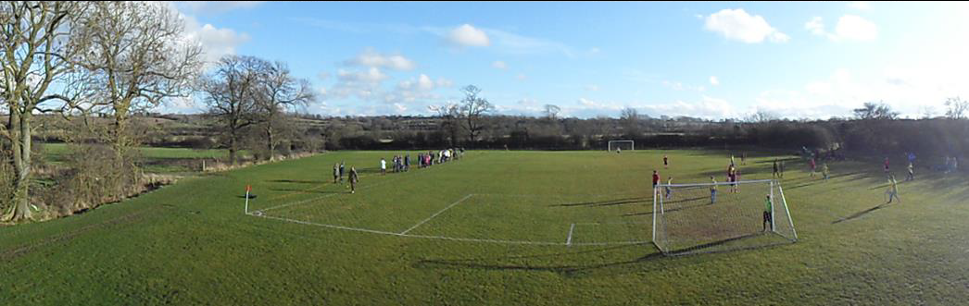



**Key Findings**

A number of factors were key to the project’s success. These include a committed membership base, continuity amongst the key members leading the project and previous experience of managing projects.

The use of a technical consultant combined with the project committee experience of project management, has helped to avoid problems the contractor with no delays in completion of phase one, despite the adverse weather conditions. The Crick Sports Field committee will continue to maintain and improve the pitches to safeguard the work that has been done and avoid future deterioration.

Crick Athletic FC has a senior’s tournament in July 2014 which will give the Club an opportunity to increase their number of member and teams and raise more money from big fundraising events. Crick Athletic FC also want to look into whether they could get some sponsors for the playing fields.

Crick Sports Field committee would have been grateful for more advance information relating to Sport England’s timetable for different funding rounds, feedback on applications and site visits.

Key challenges going forward, will be securing funding for the next phases for the pavilion, and the cricket pitch.

